

Hand-Eye Coordination in Virtual Reality

By Ryan Simms

BCS(Hons) Computer Games Technology

Faculty of Science & Engineering

Supervised by David McLean

05/04/2019

# Contents

* Introduction
* Literature Review
* Design
* Implementation
* Evaluation
* Conclusion
* References
* Bibliography
* Glossary
* Appendices

# Declaration

# Acknowledgements

I would like to thank my supervisor, David McLean, for overseeing this project.

# Table of Figures

Figure 1 – Sensorama

Figure 2 – View Master

Figure 3 – Google Cardboard Headset

# Chapter 1 – Introduction

## Project Background

Now although it is seen as something new and popular, virtual reality has been an idea for many decades, spanning way back to the 1950s. Morton Heilig, a pioneer in virtual reality, wrote in the 1950s of an "Experience Theatre" that could encompass all the senses in an effective manner, thus drawing the viewer into the onscreen activity.

The concept for my game will be where the user is in a small room and they must find a floating object within the room, every time they find that object it will teleport to a new random location within the room. There will also be objects that the user must avoid. The more objects they get the more points they will receive, hit the unwanted objects and the user will lose points. There is a one-minute time limit to keep the game short and sweet and keep the user interested.

The idea comes from hand-eye coordination tests that sports players and other professional industries use.

This machine has a timer on it and displays lights on buttons that the user must hit in a short amount of time. They must hit it within a certain time before it goes out and it increases with speed as the game goes on. As my game is in virtual reality and I want to reduce motion sickness I don’t necessarily want the game to be too fast.

## Aim

The aim of the project for me is to make a unique game that stands out to customers or clients.

## Objectives

* To research about existing hand-eye coordination games and the algorithm for randomisation.
* To create customised algorithms and mathematical equations to generate a randomised spawn for objects within the hand-eye coordination game.
* To produce a novel game to improve hand-eye coordination and sharpening reflexes.
* To investigate if this hand-eye coordination game can be a game used within a general home environment for a visually impaired patient.

# Chapter 2 – Literature Review

## Background

Quite recently virtual reality has been ever growing in popularity, being used in many different sectors and professional bodies. This includes teaching, entertainment and training. Examples such as simulators for pilots or surgeons help to see what is good and what can be improved in a real situation. Virtual reality makes the user feels immersed and what they see looks so life-like.

The technology used back in the 1800s is still used today for low budget headsets such as Google Cardboard. Due to the popularisation of video games from the 1970s until today, the idea of a totally immersive world has become realistic.

In the 1990s both Sega and Nintendo made announcements that they would try and release virtual reality headsets. Nintendo released the Virtual Boy, which became a marketing disaster. Only a year after it was released did they cease production on it as it had poor graphics and viewing the screen meant sitting in uncomfortable positions. Sega had planned to release a headset called Sega VR but only an arcade version was released, home console versions were cancelled.

It wasn’t until 2012 when the site Kickstarter was used to fund a project that would create a headset known as the Oculus Rift. When it was shown at E3, the funding increased rapidly to over 2.4 million dollars and thus made VR so popular.

Today there are many headsets that exist, such as Google Cardboard, PlayStation VR, Oculus, Steam VR and you can even buy cheap headsets like Google Cardboard from many retail stores.

## What is VR?

VR stands for virtual reality, which was coined by Jaron Lanier. It is the use of computer technology to create a three-dimensional simulated environment which can be explored and interacted by a person.

Unlike traditional interfaces, virtual reality puts the user inside an experience. Instead of just placing a screen in front of someone the user is immersed and can interact with 3D worlds. Simulation of many senses such as vision, hearing, touch and even smell creates this immersive application. The only limits to near-real virtual reality is the experiences that are available and cheap computing power.

## History of VR

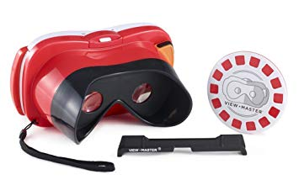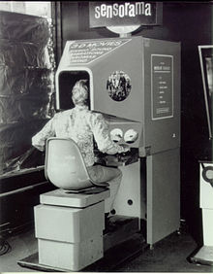Virtual reality has been something that has been around for many years but only in recent times has it improved enough that users can buy virtual reality headsets and take them wherever they please and feel immersed. In 1838 a man by the name of Charles Wheatstone stated that the brain processes a separate image from each eye and combines them into a single three-dimensional view. After this he went on to invent a stereoscope which paved the way for devices such as the View-Master, but this was only limited to viewing on picture at a time. Invented in 1962, Morton Heilig created a machine known as a Sensorama. It included a stereoscopic colour display, fans, odour emitters, stereo-sound system and a motional chair. The screen would display short films. With all these devices working within the Sensorama it made the user feel immersed within the virtual space by triggering the bodies senses.

Nowadays with phones that have gyroscopes, things such as 360o video on Facebook and YouTube and virtual reality apps make it easy to make use of a variety of headsets. Headsets, such as Google Cardboard, are so cheap and easy to setup that practically anyone can buy one and use it.

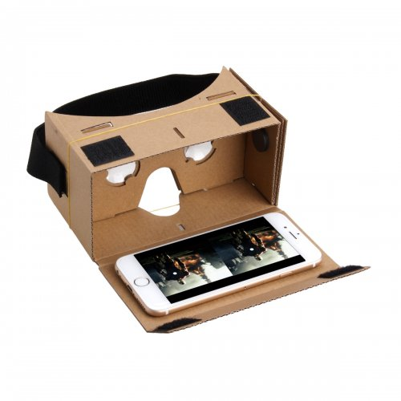

## What Makes VR Immersive?

Immersiveness is considered on a scale or along a continuum, going from no immersion to fully immersive. Usually, user engagement (an assessment of an individual’s response to something) will vary accordingly. Having an environment that isn’t immersive itself will not engage the user, while on the other end of the spectrum, one that completely replicates the real world could have unpredictable psychological effects.

Interaction within the game is also important. Interaction is meant by the amount the user can do, such as picking up and throwing an object and have it hit other objects that fall over. At one end of the scale you have something that is completely static with no interaction, at the other end you have real-time access to everything within the game.

## Why Do We Have Virtual Reality?

Virtual reality is perfect for immersive films and video games, entertainment is a multi-billion-dollar industry. However, it also helps in other fields that include:

* Architecture
* Medicine
* Sport
* The Arts

## What is Hand-Eye Coordination?

Hand-eye coordination is a cognitive skill which allows humans to do activities that require the simultaneous use of our hands and eyes. Our eyes are used to direct attention to a stimulus and help the brain understand where the body, itself, is in space. Our hands are used to simultaneously carry out a task based on the visual information our eyes receive. Hand-eye coordination is a complex cognitive ability that children develop for academic success and adults use in countless everyday activities making it an important skill to have.

### Examples:

* We use hand-eye coordination when we write. Our eyes send visual information to the brain to instruct it where to place the hand and if your handwriting is legible. The brain then generates instructions for how the hand must move to create letters and words. Visual feedback also helps corrects errors. It is a sequence of fast and precise motor actions that require a certain amount of skill.
* A very similar sequence happens when typing on a keyboard. The movements are a little different, but we still use visual information that tells the brain where to guide the hand or if a mistake has been made and needs to be corrected.
* Driving also requires hand-eye coordination. You constantly use it by giving visual information to move your hands on the wheel, keeping control of the car and avoiding accidents.

## How Can Hand-Eye Coordination Be Measured & Assessed?

Assessing hand-eye coordination is important as it gives us information if there’s a deficiency in certain areas and how it can be improved. In academic areas we will know if a child might have trouble doing certain tasks like completing homework, essays or test. In medical areas to know if a patient can drive or eat on their own. In professional areas to know if an employee will be able to properly and safely perform their job.

There are multiple known tests, these include:

* Synchronisation Test – a moving ball appears on screen and the user must keep the cursor on the moving ball.
* Simultaneity Test – The user must follow a white ball that moves around the screen, words will appear in different colours, when the word corresponds to the colour it is written in the user will have to give a response.
* Speed Test – A blue square will appear on screen and the user must click on it as fast as they can in a certain time.
* Resolution Test – Several moving stimuli will appear on screen. The user must click on the target stimuli as quickly as possible while avoiding the other stimuli.

# Chapter 3 – Design

## Required Resources

* Google cardboard
* iPhone with iOS 8 or above or an Android phone that has version 4.4 “KitKat” or above – the phone must also have a gyroscope in it
* USB cable to be able to connect the device to a PC
* To program the game Unity 2017.4 or above is required
* Not necessarily required but as a preference, headphones for in-game sound

## Level Design

The game will start within a small room. There will be a spinning object placed randomly within the room. There will be ambient lighting within the room. The user must interactive with the object within the room. Once the object has been interacted with it will move to another random location within the room.

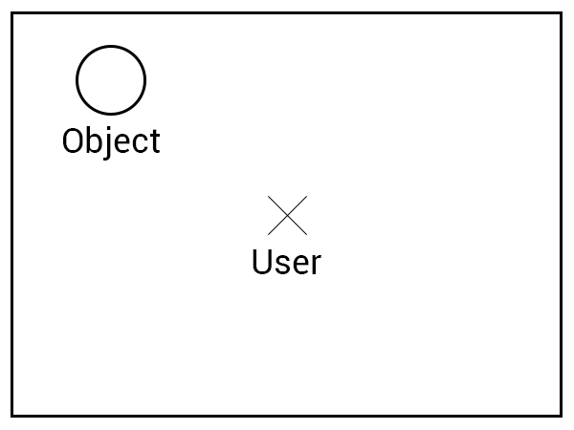

Here is what the game would look like when looking from above. The user will be in the centre of the room while the objects appear randomly around the user. The user will be low to the ground, so the ball can spawn directly above them as well. It is a very basic design as I want to keep the game basic itself so that it’s easy to play and not overcomplicated.

## Pseudo Code – Randomness Script

* Spinning object within the room
* Player navigates to the object
* Player interacts with the object
* Sound to indicate interaction
* Object moves to another random location
* Over time, the objects appear quicker and quicker

I’m uncertain whether I will increase the speed in which the objects are spawned or if I do implement this then I don’t want it to be too fast, or it may cause motion sickness, something I have expressed that I want to avoid. It may be a gentle increase of speed.

I also want to use my own mathematical formula instead of just using the built-in ‘Rand’ function that Unity offers. I want to base the randomness off the time elapsed within the game and based off the previous object’s position.

I may also implement objects the user has to avoid as this will include more difficulty within the game, users will have to differentiate between objects. I want to try and make this game available to all people, so the colours used between the two types of objects will have to be colour-blind friendly.

The use of a sound to indicate interaction makes it easier for people to know that the object is moved and that they should look around for a new one.

## Pseudo Code – Points System

* Player interacts with object
* X amount of points added to score
* Points added dependant on how fast player interacts with object once spawned

The point system used will determine which player has the highest reflexes and best hand-eye coordination. The higher the score the better. Each game will start off with the player having 0 points. The quicker the player can identify the object and interact with it the better score they will get.

## Pseudo Code – Main Menu

* 3 Buttons when game loads
* 1st button says ‘play’ on it, takes the user into the game
* 2nd button says ‘options’, here the user can control sounds and other miscellaneous stuff
* 3rd button says ‘instructions’, this will give a brief intro on how to play the game
* 4th button says ‘quit’ allows the user to quit out the game quickly and effectively

I want to keep the menu simple, I don’t users spending a lot of time here and getting confused with too many options. Things like controlling of sound would be useful as not everyone will want game sound. Other options may include things such as brightness. The instructions option will show some text on screen and will help the user know what they’re doing before they press play.

# Chapter 4 – Implementation

## Prototype

For my initial prototype I created a small room with some ambient lighting that contains a spinning ball, this is interactive as the Google reticle reacts when the user hovers over the object. When the user clicks on the ball it disappears. From here I am going to implement a feature that makes the ball move to a different location instead of it being removed. I also will reskin the ball.

The prototype contains sound and a menu however the menu shows up correctly on the desktop version of unity while it does not on the mobile version of the game. Because of this, I will have to try and find a new way to display the menu and begin the game.



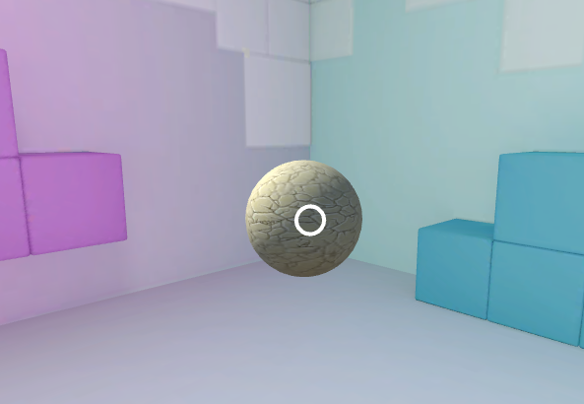

# Chapter 5 – Evaluation

# Chapter 6 – Conclusion

# References

Marxent. 2018. *What is Virtual Reality? VR Definition and Examples | Marxent.* [ONLINE] Available at: <https://www.marxentlabs.com/what-is-virtual-reality/>. [Accessed 16 October 2018].

Virtual Reality – Wikipedia. 2018. *Virtual Reality – Wikipedia.* [ONLINE] Available at: <https://en.wikipedia.org/wiki/Virtual_reality>. [Accessed 17 October 2018].

Hand-eye Coordination – Cognitive Skill. 2018. *Hand-eye Coordination – Cognitive Skill.* [ONLINE] Available at: <https://www.cognifit.com/science/cognitive-skills/eye-hand-coordination>. [Accessed 17 October 2018].

WhatIs.com. 2018. *What is immersive virtual reality (immersive VR)? – Definition from WhatIs.com.* [ONLINE] Available at: <https://whatis.techtarget.com/definition/immersive-virtual-reality-immersive-VR>. [Accessed 18 October 2018].

Virtual Reality Society. 2018. *Who Invented Virtual Reality? – Virtual Reality Society.* [ONLINE] Available at: <https://www.vrs.org.uk/virtual-reality/who-invented-it.html>. [Accessed 18 October 2018].

Sega VR – Wikipedia 2018. *Sega VR – Wikipedia.* [ONLINE] Available at: <https://en.wikipedia.org/wiki/Sega_VR>. [Accessed 10 November 2018].

Virtual Boy – Wikipedia 2018. *Virtual Boy – Wikipedia.* [ONLINE] Available at: <https://en.wikipedia.org/wiki/Virtual_Boy>. [Accessed 10 November 2018].

Virtual Reality Society. 2018. *What is Virtual Reality? – Virtual Reality Society.* [ONLINE] Available at: <https://www.vrs.org.uk/virtual-reality/what-is-virtual-reality.html>. [Accessed 14November 2018].

# Bibliography

# Glossary

# Appendices